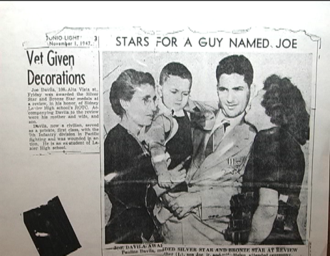
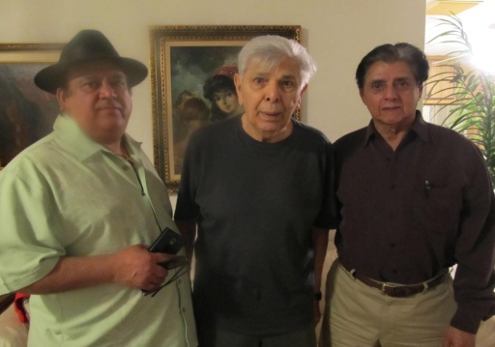
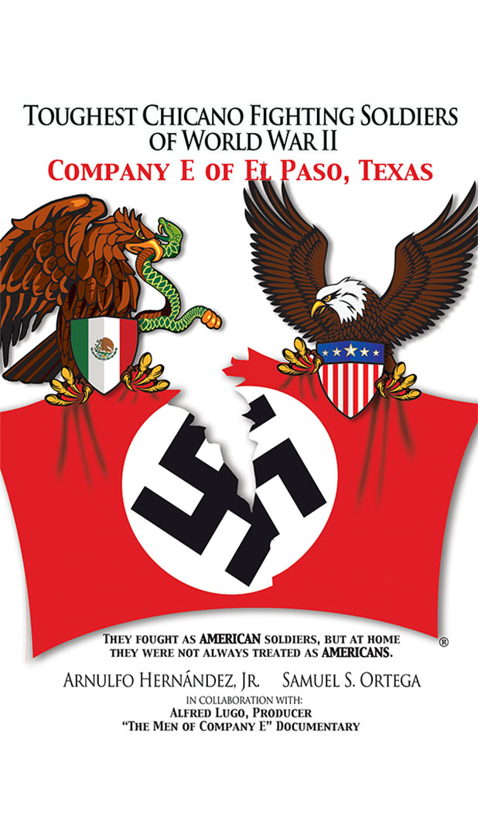

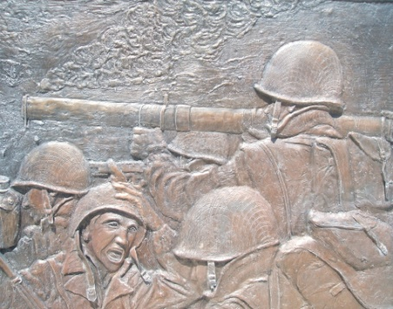
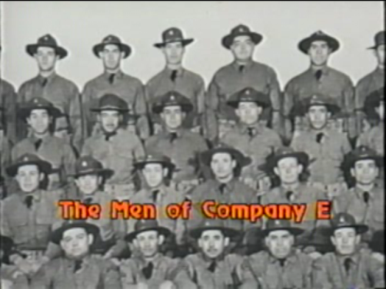

AUTHORED BY ARNULFO HERNÁNDEZ, JR. & SAMUEL ORTEGA
IN COLLABORATION WITH PRODUCER ALFRED LUGO OF THE DOCUMENTARY
“THE MEN OF COMPANY E” & FREDDIE MORALES, EL PASO HISTORIAN

The authors will be in El Paso for a book-signing event as follows:
BOWIE HIGH SCHOOL, FINE ARTS BLDG, THUR, AUGUST 13, 2015, TIME: 6-9:00 P.M.
801 SAN MARCIAL, EL PASO, TEXAS 79901
CONTACT: BOWIE HIGH SCHOOL (915) 236-7000; ABE LUEVANOS (915) 241-8245; ARNULFO HERNANDEZ (916) 616-4211
The program will include a 30 minute panel discussion with the authors and invited guests and a Q & A period. The authors will be available after the program to autograph their book, priced at $20.00.
PARKING: Free on campus on a first come basis.
The story of Company E in WW II is the history of American, local heroes that must be told. The book provides a unique insight to Mexican-American, Chicano soldiers in WW II. The book chronicles and profiles the courage of young Texas Chicanos, many from El Paso, others from South Texas towns, who answered their country’s call to duty in World War II in the name of patriotism- American patriotism!

The event is co-hosted by Bowie High School and the Bowie High School Alumni Association

###

