WOLF GALLERY

PRESENTS

“HONORING THE MEXICAN-AMERICAN SOLDIER”

AN EXHIBIT HELD TO HONOR THE SPIRIT AND VALOR OF THE MEXICAN-AMERICAN SOLDIERS WHO HAVE FOUGHT OR SERVED IN AMERICAN WARS-FROM WORLD WAR I TO PRESENT DAY IRAQ

OPENING EXHIBIT ON SATURDAY, JULY 12TH 2008
6:00 PM TO 10:00 PM

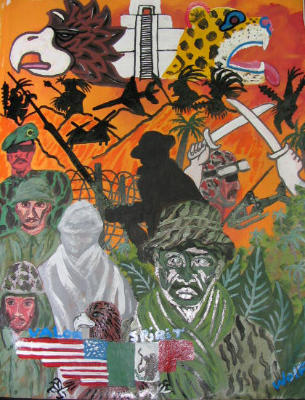

Featured artists
CARLOS “WOLF” SANCHEZ

DANNY FLORES
ROLLANDO CANO

LORENA GUADIANA

DANNY MARTINEZ

MARTIN ROMO
CINDY MALDONADO

STEPHANIE AMEZCUA

RICK ESPINOZA
CARLOS SANCHEZ JR.

6:00 PM TO 7:00 PM
LOCATED AT
*********
WOLF GALLERY
7646 GREENLEAF AVE.
WHITTIER CA 90602
(562) 945-7155
*********
THIS IS A FREE EVENT!!
REFRESHMENT WILL BE PROVIDED
ALCOHOLIC BEVERAGES WILL BE AVAILABLE FOR A DONATION
*********

PLEASE CONTACT US FOR MORE INFORMATION

EMAIL: WOLFGALLERYSANCHEZ@YAHOO.COM
TRADITIONAL INDIGENOUS CEREMONY
OF HONOR PERFORMED BY THE
UNITED MEXICAN-AMERICAN

VETERANS ASSOCIATION

8:30 PM TO 10:00 PM
MUSICAL PERFORMANCE BY XUE

XUE
(LATIN EXPERIMENTAL ROCK)

