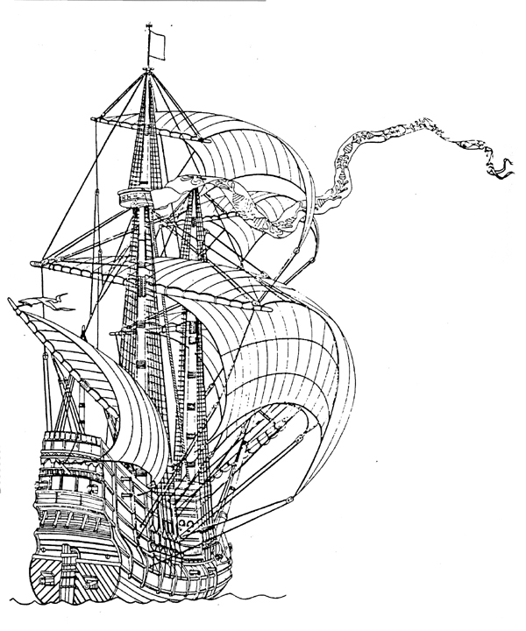
Heritage Discovery Center, Inc.
40222 Millstream Lane, Madera, CA 93636
559.868.8681 • hdcincrlc@aol.com
www.heritagediscoverycenter.com

Promoting Education, Preservation, Conservation
Robin Lea Collins, President and Founder
The Purpose in Designing this “Living History Museum” is to:

- Enlighten with sage discretion
- To inform; the ultimate power of change lies in the hands of the people
The museum was conceived with a very direct purpose – to foster an understanding and wise stewardship of the region’s history and resources. With a greater depth of understanding, people are better equipped to decide the course of the future.
The museum is designed to bring alive the unique heritage of our California Colonial Spanish period through a wide range of exhibits and programs about our cultural and natural history orchestrated to represent and embody our diversity.
For some 10,000 years, these lands were the provinces of skilled and resourceful groups of Native peoples. The museum areas will include the subjects of Nature/Wildlife, Native American cultures, Missions, Ranching, Agriculture, Maritime and Military. The themes of animal and equine participation will be noted and demonstrated throughout the total experience.
The broad, cross-disciplinary nature of the museums offerings will not only enhance the visitors experience but also provide enormous opportunity for educational programming, exhibitory, acquisitions of collections and scholarly research, underscoring the museum’s role as steward of the region’s natural and cultural heritage.
The museum’s approach to its diverse subject matter is participatory and interactive, punctuated with live animals and living history presentations, immediately you are not a visitor, but a part of the experience.
As well as the architectural exhibits, a blend of natural and man made ecosystems will provide habitats for a wide variety of native plants and animals.
The museum’s exhibits will tell the stories of the hardy groups of peoples and of the inspired poets, painters and entrepreneurs who have long taken advantage of the new markets, abundant resources, and burgeoning populations.
The museum is based on an educational philosophy that places at least as much emphasis on experience as it does on knowledge that seeks to empower, engage and to responsibly teach. Thus making our colonial history more accessible by providing educational experiences not available through other institutions.
The museum will present these subjects and themes in a diverse way to a broad audience, thus developing tolerance of our cultural differences and enriching the lives of generations to come.

